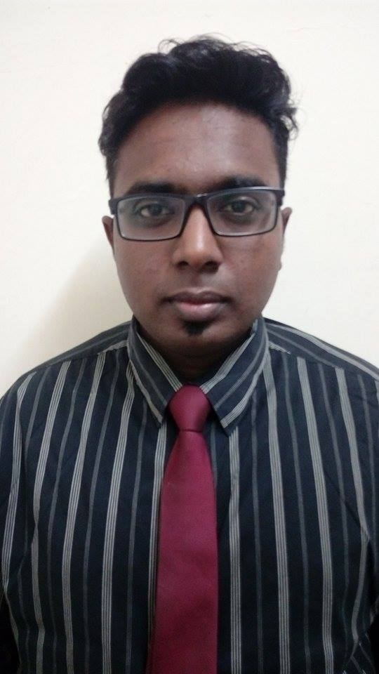

PERSONAL INFORMATION

Name : Thiru Kumaran A/L Palaniandy
Gender : Male
Age : 26
Date Of Birth : 17th November 1990
IC : 901117-10-5323
Marital Status : Single
Nationality : Malaysian
E-mail : jikumara.tk@gmail.com
Mobile : 014-3342256
Current Address : No.52, Leboh Selar, Kaw.7 Taman Bertek. 41100.
Klang.Selangor.

EDUCATIONAL BACKGROUND

Multimedia University, Cyberjaya

Qualification : Bachelor Engineering (Hons)
Field Of Study : Electrical
CGPA : 2.31

MANAGEMENT SCIENCE UNIVERSITY

Qualification : Diploma in Engineering
Field Of Study : Electrical and Electronic
CGPA : 2.43

CAREER OBJECTIVES

Looking for career opportunity to gain more knowledge and experience.

STRENGTH

- Good and fast learner
- Good communication skills
- Able to apply financial knowledge
- Able to work independently or in a group
- Always punctual
- Interested to learn new knowledge
- Hardworking in completing task

PERSONAL TRAITS

Well organized in managing assignments and practically in doing anything. Adapt easily to a new group of environment and am flexible working at any time of the day and can cope with pressure in relation to work. Studying in MMU has brought me the chance to see how punctuality and efficiency plays a major factor in succeeding thus made me become such a person with these traits. Furthermore this experience has taught me to think beyond the limits in participating and approaching any situation and also to think optimistically as well as to grab any opportunity available.

SKILLS

- Computer Literate : Microsoft Word, Excel, Powerpoint

ACHIEVEMENTS

University Level:

- Head of Members Welfare Bureau in IEM (INSTITUTION ENGINEERING (MALAYSIA) student section MMU CYBERJAYA. 2016/2017
- Co-Director for COMMUNITY SERVICE (THE HERBS GARDEN PROJECT),THE HERBS PARK,(MSU), SHAH ALAM.(2011)
- TREASURER for SPORTING EVENTS(SPINNING BALL AT SPACE U8),(MSU), SHAH ALAM.(2012)

School Level:

- School Prefect (2004-2007)
- Representative form 3 for badminton club (2004/2005)
- 2nd runner up for inter school badminton competition year 2004,2005 and 2006
- Champion hockey (MSSD) under 18, 2007.
- National Service, 2008.

Reference

Name : Mr. C.Senthilpari
Position : Senior lecturer
Company : Multimedia University , Cyberjaya
Tel (Office) : 03-83125943

